

Group 8;
CI6415 – Digital Entrepreneurship
TB2 Business Plan

Group Members:
Name: | Student ID:
Mohamud Elmi | K2121774
Yusuf Salad | K2230876
Abdilahi Ahmed | K2226138
Isa Ebrahim | K2273123
Khalid Mohamed | K2276611
Abdullahi Mohamed | K2032542

Contents

Executive Summary 3
Introduction 4
Market Overview 6
Market Segmentation 6
User Role Segmentation 6
Geographic Segmentation 7
Healthcare Setting Segmentation 8
Marketing & Go-to-Market Strategy 9
Business Model, Structures and Funding 12
Competitive Analysis and Risk Management 19
SWOT Analysis 21
Conclusion 23
References 23

Executive Summary
The IV Toolkit business plan presents our precise approach to market our advanced IV medication preparation instrument for commercial use. The IV Toolkit serves to decrease medication preparation duration while preventing mistakes and optimising hospital operational procedures because it solves an essential healthcare requirement. Our detailed approach indicates definite market potential and excellent financial modelling with focused market entry techniques for a medical niche segment that builds substantial return opportunities for investors.
This document demonstrates our dedication to outstanding performance as it unites comprehensive market studies with competitive assessment alongside comprehensive risk prevention systems. The document proves competent understanding of customer needs and establishes a sustainable operation that maintains operational efficiency as well as scalable growth. This executive summary introduces investors to the business plan via clear data-backed insights which establish an interesting foundation for comprehensive review.
In 2022, a paediatric nurse at a major NHS hospital mistakenly calculated a child’s IV dosage using a standard calculator and printed guideline sheets under time pressure. The error was only caught after the medication had been administered, prompting an internal review. While the child recovered, the incident highlighted the urgent need for a tool that automates paediatric dosage calculations, reducing cognitive load and human error. The IV Toolkit was developed in response to these recurring issues, integrating verified guidelines directly into a digital workflow to prevent similar occurrences (NHS England, 2022).
During informal interviews conducted in Semester 1, our team spoke with NHS paediatric nurses about the challenges they face preparing IV medication. One nurse described juggling dosage charts, handwritten notes, and multiple apps as “a disaster waiting to happen.” Several participants noted that stress, fatigue, and environmental noise often lead to calculation mistakes or time delays. These insights directly shaped the IV Toolkit’s features—specifically its weight-based calculator, embedded BNFC/Medusa guidelines, and audit log for medication history (Group 8, 2024).

Introduction
The present healthcare environment demands both rapid operation and precise execution. Healthcare professionals and their nursing colleagues face daily struggles during IV medication preparation which produces both long durations of work and various possible mistakes. Our team built the IV Toolkit which provides users with a simple application featuring necessary clinical instructions through an optimised interface. The Toolkit streamlines IV preparation procedures which both decreases time requirements while improving safety practices and resulting in overall better hospital operational effectiveness.

The business plan exists to turn the promising IV Toolkit predecessor into a market-ready product. The document presents our fundamental goal of developing a sustainable business enterprise designed to meet existing market requirements specifically tailored for investors. Our plan demonstrates how we will benefit from major healthcare industry expansion opportunities through targeted marketing of our product. Fundamental market examination and client segmentation enable us to discover first adopters and generate fast market entry while building robust brand trustworthiness.
Different main segments receive detailed information distribution throughout the report. A thorough market analysis based on Total Addressable Market estimation allows us to segment key business groups. The section illustrates available business potential through evidence proving customer requirements for this product. We developed distinct approaches for marketing and market entry strategies within our plan so we can maintain contact with our selected target customers effectively. A brand message development requires synchronised implementation stages that create growing momentum from the beginning.
We detail ahead of time the operational setup combined with funding strategies and monetary projections, which maintain our main business activities after implementation. The IV Toolkit will achieve both financial self-sustainability and expansion potential through components that correspond with larger market potential. Our strategy includes protection against marketplace threats which details how we will defend our company against competitive forces effectively.
As part of the plan, we firmly dedicate ourselves to maintain ongoing development. Our organisation will conduct continuous market research to enhance customer engagement approaches and modify operational procedures because we aim to stay competitive. The report terminates with strategic initiatives and the following stages for achieving this opportunity.
This plan provides available information to investors by emphasising market opportunities throughout strategic implementation steps instead of detailing minor matters. The value proposition of IV Toolkit stands clear while demonstrating our capability to execute this plan thus guaranteeing a successful long-run growth and robust economic return.

Market Overview
The healthcare industry together with its paediatric care department now heavily depends on digital tools to enhance efficiency while minimizing errors for better patient outcomes. The IV Toolkit functions as a solution to handle an important market requirement that involves precise and efficient intravenous (IV) medication preparation for children. The application combines BNFc and Medusa guidelines with calculation functions to create an exclusive tool designed for paediatric nurses.
The Total Addressable Market (TAM) for the IV Toolkit spans across all paediatric nurses along with other health care professionals operating in the United Kingdom who need use of the application. There exists approximately a £3 million annual opportunity for the IV Toolkit app within the United Kingdom because it targets both the 40,000 paediatric nurses and 20,00other Emergency and intensive care healthcare staff members make up the target audience of this application. The application offers subscriptions to professionals who need to pay £50 per year.
The market potential exceeds British domain boundaries since it extends internationally. Healthcare facilities that serve children are growing across the world because medical profession requires digital tools that reduce drug administration problems and boost operational speed. Nationwide between the United States and similar developed nations count their paediatric nurses in numbers exceeding 100,000. The IV Toolkit aims to extend its service area outside UK territory thus creating an expected annual market value above £10 million.

Market Segmentation
Multiple market segments exist for the IV Toolkit, including roles of users as well as geographic areas and healthcare delivery environments. The segments enable a clear view into different user needs to enable specific feature adjustments for the app.

User Role Segmentation
Pediatric Nurses:
Pediatric nurses serve as the main target audience group for the IV Toolkit system. Pediatric nurses receive their responsibility to administer IV medications to children that needs fast access to precise dosage calculations and treatment guidelines. - Needs: Pediatric nurses need a tool that is easy to use, integrates seamlessly into their workflow, and reduces the risk of medication errors. They value features like weight-based dosage calculations, quick access to guidelines, and the ability to bookmark frequently used medications.

Hospital Administrators:
The hospital administration team serves as secondary users who must verify that all staff tools function with efficiency along with security and regulatory compliance.
The hospital administrator needs a tool which consolidates with existing hospital framework and secures all database information and tracks user activities for audit purpose and compliance needs. The administrators review both solution cost-effectiveness factors and operational efficiency improvements that will impact hospital operations.

Other Healthcare Professionals:
The third group of users consists of healthcare professionals who work in emergency medicine settings together with intensive care units and different environments where pediatric patients receive treatment.
The tool should fulfill needs of these users through its ability to work across multiple clinical settings with precise content about medicines and patient medical conditions.

Geographic Segmentation
United Kingdom:
The IV Toolkit finds its principal use in United Kingdom markets since it fulfills NHS guidelines and connects with BNFc and Medusa. Digital transformation goals of the NHS create a substantial market demand for the app's implementation.
Approximately 40,000 pediatric nurses together with 20,000 other healthcare workforces in the UK generate an annual market TAM worth £3 million.
Developed Countries:
The IV Toolkit should seek entry into Canadian and Australian healthcare markets along with Western European ones since these regions share healthcare standards and regulatory protocols with the UK.
Combined UK markets extend the potential client addressable market to include £2-3 million.

Healthcare Setting Segmentation
Hospital Wards:
The main use setting for the IV Toolkit exists in pediatric hospital wards across medical facilities. Hospital nurses need fast and correct access to medications and calculation data because of their work environment demands.
The app needs to function with hospital IT systems by delivering real-time information which merges into current operational procedures.
Emergency Departments:
Urgent Intravenous treatments necessitate emergency department care of pediatric patients regularly. The application needs to operate in time-sensitive emergency situations requiring fast choices from medical staff.
A set of necessary performance features including fast search capabilities, quick medication calculations and instant guideline access are vital requirements for emergency department users.

Customer Personas
Our research combined with past work has enabled us to create a customer persona which represent the target market behaviour and requirements.
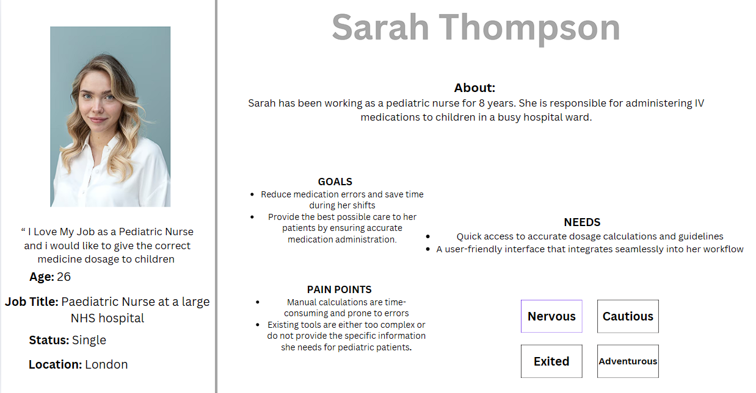

Marketing & Go-to-Market Strategy
The IV Toolkit’s marketing strategy is built on targeted engagement and strategic scaling to establish early value delivery. To yield the best results we chose a approach that prioritizes deep collaboration with NHS Trusts and hospitals. This niches down our targets for the best results, ensuring meaningful interactions with key decision-makers such as supply chain teams, nursing staff, and administrative leaders. The reason we niched our focus on these individuals is because they have direct power to bring our product into use making them our primary targets. Securing NHS Trust contracts is central to our expansion plan, as it enables entry into multiple hospitals, accelerating widespread adoption.

To support this, the team will execute pilot trials in NHS paediatric wards, offering free testing periods for healthcare staff to assess the IV Toolkit in real-world settings. This hands-on experience will not only validate its effectiveness but also provide critical feedback from nurses and administrators, allowing for continued product optimization. Data gathered from these trials—highlighting improvements in medication accuracy and workflow efficiency—will serve as concrete evidence for NHS-wide implementation. Additionally, the team will leverage high-profile medical events like the NHS Innovation Expo and key healthcare conventions to introduce the IV Toolkit to industry stakeholders. Live webinars and demonstrations will further engage NHS administrators and procurement teams, presenting real-world case studies and testimonials that reinforce the toolkit’s value.

A multi-layered digital strategy will enhance credibility and visibility among healthcare professionals. The marketing team will develop high-quality, research-driven content for LinkedIn and healthcare forums, positioning the IV Toolkit as an indispensable resource for paediatric nurses and NHS hospitals. This will be combined with a targeted SEO strategy, ensuring strong search visibility for queries related to IV medication tools and NHS digital solutions. Additionally, personalized LinkedIn outreach and email campaigns will help establish direct connections with hospital decision-makers, further strengthening adoption efforts.

By blending strategic partnerships, real-world validation, and a focused digital presence, the IV Toolkit will secure its position as a trusted, go-to solution in paediatric IV medication management, ensuring long-term success within NHS healthcare facilities.

Customer Acquisition Tactics
The customer acquisition strategy for the IV Toolkit is built on a mix of direct outreach, pilot programs, partnership with influencers to spread word of mouth and incentive systems to encourage hospitals to take on our product and build trust with the NHS.The objective of the first strategy is to acquire personal connections with NHS decision through conferences, events, webinars and individual outreach makers. At events like the NHS Innovation Expo, we will showcase the toolkit through live demonstrations and direct interactions with administrators and procurement teams. These engagements will be supported by case studies and testimonials that highlight the toolkit’s value, helping decision-makers see its value.
A key component of our strategy is the implementation of pilot programs, which will offer free real world testing opportunities to selected paediatric wards within NHS hospitals. These trials will help nurses and administrators gauge if the toolkit meets real operational needs.
The data collected from these pilot programs will be published to show its capabilities and get feedback from the public on errors and improvements. Credibility and trust will be key in our branding, to achieve this we will engage in influencer and community marketing. This includes collaborating with nurse communities at the Royal College of Nursing (RCN) and partnering with respected paediatric nurse influencers who can advocate for the toolkit. Educational resources such as blogs, case studies, and whitepapers will be used to showcase the toolkit’s benefits. Additionally, we plan to launch a nurse referral program, offering hospitals price reductions when their employees promote the toolkit to other healthcare professionals. Early adopters among NHS Trusts will also receive added value through cost reductions and official NHS recognition, positioning them as leaders in digital healthcare innovation. These incentives are designed to accelerate initial adoption and encourage widespread use.

To build initial traction and scale adoption efficiently, the IV Toolkit will also focus on targeted email campaigns and educational webinars tailored to paediatric healthcare professionals. These webinars will highlight real-world use cases and demonstrate the toolkit’s impact. Social media platforms like LinkedIn and Twitter will be leveraged to engage with the medical community, build credibility, and increase brand awareness. Strategic PR efforts will further establish the toolkit’s reputation by securing coverage in prominent healthcare publications.

The branding strategy positions the IV Toolkit as the gold standard for IV medication preparation in paediatric healthcare. Messaging will emphasize precision and safety, showing the toolkit’s role in eliminating medication errors. It will also highlight timesaving and efficiency benefits, demonstrating how the toolkit reduces preparation time and streamlines workflows. Trust and compliance will be reinforced by making sure the product complies with NHS, BNFC, and Medusa guidelines. The product UI will consist of a cheque and modern aesthetic feel, making it more trustworthy. The colours will consist of blue and white, which are colours attributed to calmness and professional feel. The messaging will be concise and to the point, to ensure that any medical professional using it can understand it. If all these strategies are executed properly and to the hight standard, it will launch the IV toolkit into the stage of the medical world ensuring its place in every hospital as an indispensable product.

Positioning in the Healthcare Market
The IV Toolkit establishes itself as the highest standard for IV medicine preparation which targets pediatric care with its distinctive value proposition. Our system's advertising platform concentrates on two key points: safety and accuracy which depicts the toolkit's mistake-preventing abilities for IV delivery preparation. The toolkit works efficiently to cut down calculation periods so nurses can dedicate their time to patient medical support. The toolkit will incorporate BNFC Medusa and NHS requirements as its main emphasis to ensure NHS hospital regulatory compliance. We will focus on usability to demonstrate how the toolkit features an interface that functions smoothly with hospital operational practices.
A medical-grade blue and white colour combination with clean branding which follows NHS digital standards will form our professional visual representation. The messaging method will maintain data integrity through evidence-based content which explains factual benefits instead of relying on shallow claims. The positioning will establish the IV Toolkit as a vital instrument that nurses in paediatric care and NHS hospitals perceive as their primary source of trust.
Early Traction Plans
We will start beta testing with NHS nurses to conduct actual testing which will collect vital feedback and testimonials for product improvement. The received feedback will guide product improvements to guarantee the product aligns with its users' needs. The toolkit's functional efficiency along with its ability to decrease errors will be presented through whitepapers with quantitative evidence. The presented documents represent essential instruments to demonstrate the toolkit's worth to NHS decision authorities.
The main focus will be to receive NHS procurement approval which will result in institutional listing of the toolkit. Streamlined adoption procedures through this step will help hospitals easily put the toolkit into operation. Using medical forums together with LinkedIn as platforms will enable us to build authentic expertise while presenting use case examples that demonstrate the toolkit's effective outcomes. Hospitals that accept the toolkit commitment will receive initial demand discounts from our company. The offered incentives will drive quick adoption which creates momentum towards establishing the toolkit throughout other NHS facilities.

Business Model, Structures and Funding
The IV Toolkit will operate as a private limited company (Ltd) registered in the United Kingdom. The legal structure offers important benefits such as limited liability, the ability to provide shares for external investment, and operational independence. This is a significant factor for scaling in healthcare environments. Successful investment relies on credible, execution ready teams. Our team combines both expertise in healthcare delivery, digital development, and entrepreneurship. Future employees will include a compliance officer and DevOps engineer to support scale up and NHS digital security requirements. Our leadership team consists of individuals with backgrounds in healthcare delivery, app development, and digital strategy, ensuring a balanced decision.
We will operate a Software-as-a-service (SaaS) business model. The IV Toolkit is a web and mobile cloud-hosted application that combines trusted resources like BNFC and Medusa with weight based IV dosage calculators and audit logged activity. It is made available via institution level licensing to NHS Trusts and other healthcare institutions, with access provision made to hospital staff through secure accounts. This model aligns with the NHS buying behaviour and enables scalable deployment to ward and facilities. (Kimes, S.E)
A dedicated backend includes user administration, analytics, and secure compliance features to drive adoption and retention. Infrastructure runs on GDPR-conformant cloud platforms with built-in safeguards for role-based access control and multi-factor authentication (MFA).
Revenue Model
We will monetise using subscription-based pricing, with NHS Trusts or hospital groups subscribing yearly. Pricing tiers are formed by usage volume: (Van der Meulen)
- Per-user model: £180/year per nurse or clinical staff member
- Advanced Analytics Add-on: Additional insights and reporting sold as a premium feature
- A free pilot trial will be offered to NHS facilities during rollout. This encourages engagement while gathering testimonials and effectiveness data.
Updated Cost Structure
To introduce the IV Toolkit to the market and secure NHS institutional adoption, a newer and revised cost plan has been produced to reflect NHS compliance, data protection, and successful pilot trial execution.
Category | Cost (£) | Details
App Development (MVP) | £2,877 | Core functionality, BNFC/Medusa API integration, UI/UX
Website & CRM Integration | £405.09 | Frontend site, CRM setup for Trust onboarding and stakeholder engagement
Security & Compliance | £182.29 | GDPR setup, SSL certs, MFA, NHS DSPT audit readiness
Testing & Deployment | £72.92 | App testing, bug fixing, app store fees, pilot deployment
Marketing & NHS Outreach | £109.37 | NHS Expo events, webinars, branded materials, LinkedIn/email campaigns
Pilot Trial Support & Training | £100 | Onboarding resources, training sessions for NHS staff via video.
Hosting & Maintenance (Year 1) | £1539.56 | App and Website maintenance as well as hosting.
Customer Support | £1,000 | Helpdesk and customer support
Legal & IP | £182.29 | Contracts, NHS compliance, data licensing, trademarks
Contingency & Risk Buffer | £531.48 | Extra for delays, re-testing, or NHS-mandated changes
Total Year 1 Cost Estimate | £7,000 | NHS pilot ready with regulatory safeguards, branding, and stakeholder buy-in
Cost Validation & Source
The total cost estimate of £7,000 is based on benchmarking against freelancer pricing found on platforms such as Fiverr. Each service, including UI/UX design, app development, integration, deployment, and compliance, was cross-referenced with actual quoted averages.
This refined model is based on extensive cost research and developments in IV Toolkit. These prices are roughly based off priced plans that freelancers offer on Fiverr. The cost is not fixed and could vary depending on whether the freelancer requests more money. We ensure that spending reflects our development, institutional engagement, regulatory needs, and NHS adoption.
Funding Strategy
We plan a two-phase investment strategy aligned with our rollout goals as highlighted in Lecture 6, “funding is milestone-driven with capital allocation tied to specific growth activities such as Trust onboarding or MVP validation”:
Phase 1 – Investment (£7,000*)
To fund development, compliance, pilot support, and outreach, we will approach to receive early-stage funding from:
- Angel investors in digital health
- NHS Innovation Accelerator funds
- University enterprise grants or tech incubators
The key use of funds will be to:
- Finalise MVP (mobile and web)
- Integrate API and security features
- Conduct NHS pilot programs
- Run initial outreach campaigns

Figure 1: Financial Projections & Growth Strategy.
Year | NHS Trusts | Revenue (£)
1 | 5 | 117,000
2 | 10 | 234,000
3 | 15+ | 350,000+
The average estimate of paediatric nurses across 5 NHS trusts is 650. I multiplied that by £180 (price per subscription per nurse)

Figure 2: Use of Funds Breakdown – A pie chart showing exactly how the £7,000 funding will be allocated across key areas.
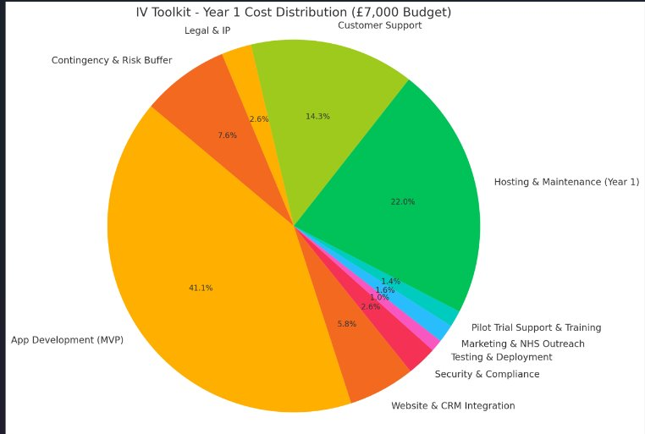

Phase 2 – Growth Round (£50,000*+)
After successful pilot results and early Trust adoption, we will continue a second round of funding to:
- Expand to new NHS Trusts
- We would like to keep the freelancers on retainer, as it would make it easier for the entire business. This would be easier for updates or any changes to make as they know what's going on. With the budget, we won't be able to hire them full-time.
- Begin international regulatory readiness (e.g., CE/FDA certifications)
This managed approach allows us to build credibility through measurable impact and adjust our strategies based on NHS feedback.

Financial Projections & Scalability
With an initial goal of 5 NHS Trusts (avg. 130 users each), our Year 1 revenue could reach £117,000. Given our SaaS model's low marginal costs, profitability can be achieved by the middle of Year 2 if our expansion targets are met.
We expect to reach 15+ NHS Trusts by Year 3 with the support of testimonials, peer adoption, and inclusion in NHS procurement frameworks. The system is designed for international scalability, targeting healthcare systems with similar paediatric standards in Canada, Australia, and the EU.
Pilot and trial run costs are justified, as we will develop a step-by-step guide based on the discovery report provided by the testers. Background commentary will be included throughout. This approach will be more cost-effective.

Figure 2: Revenue Forecast by Year: A bar chart projecting revenue growth from Year 1 to Year 3 based on NHS Trust adoption.
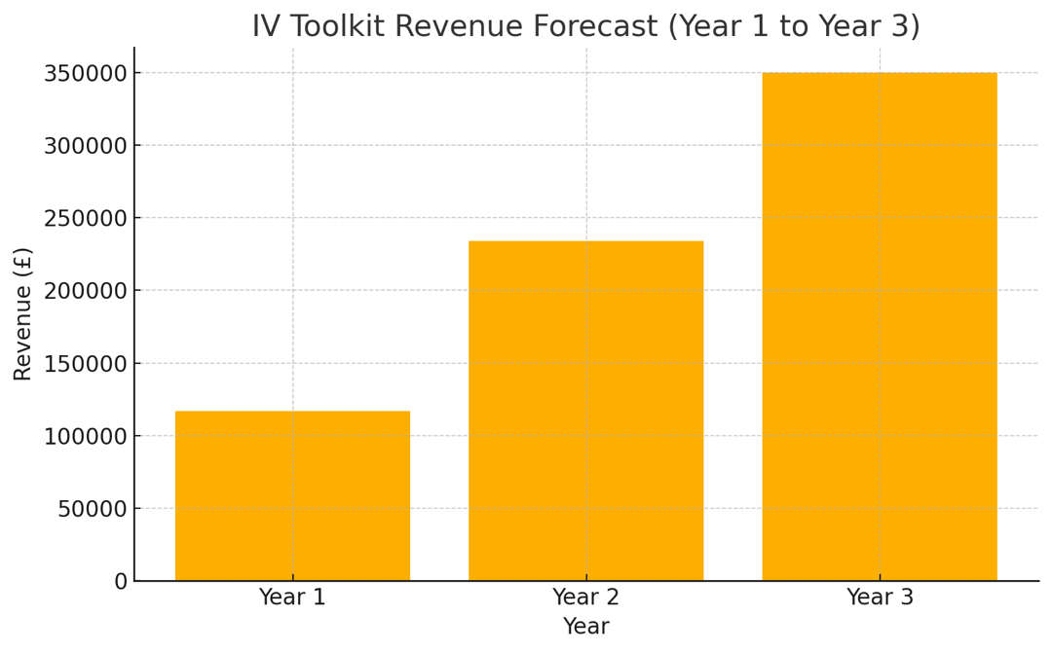

Figure 3: Project Rollout Timeline: Gantt chart showing each key phase of the IV Toolkit development and launch, from seed funding through national scale-up.
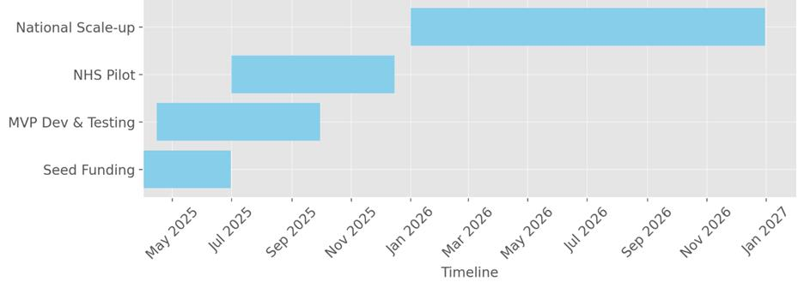

Figure: Website Development
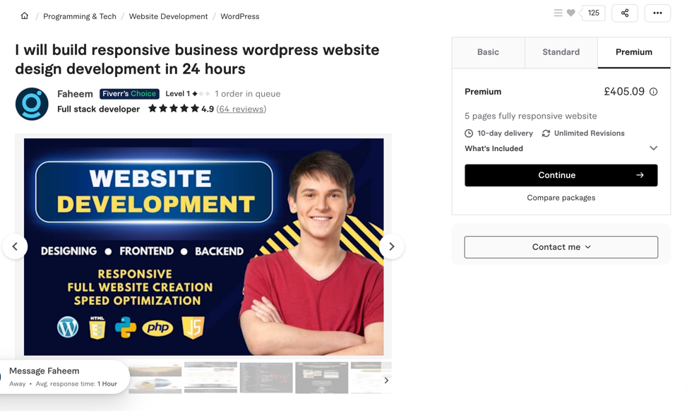

Figure: App Development (MVP)
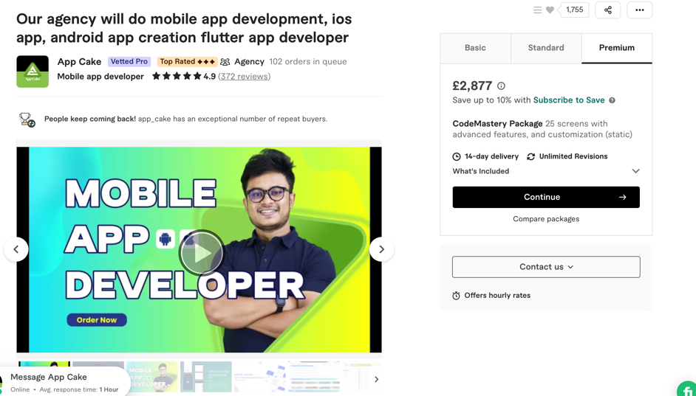

Figure: Web Maintenance
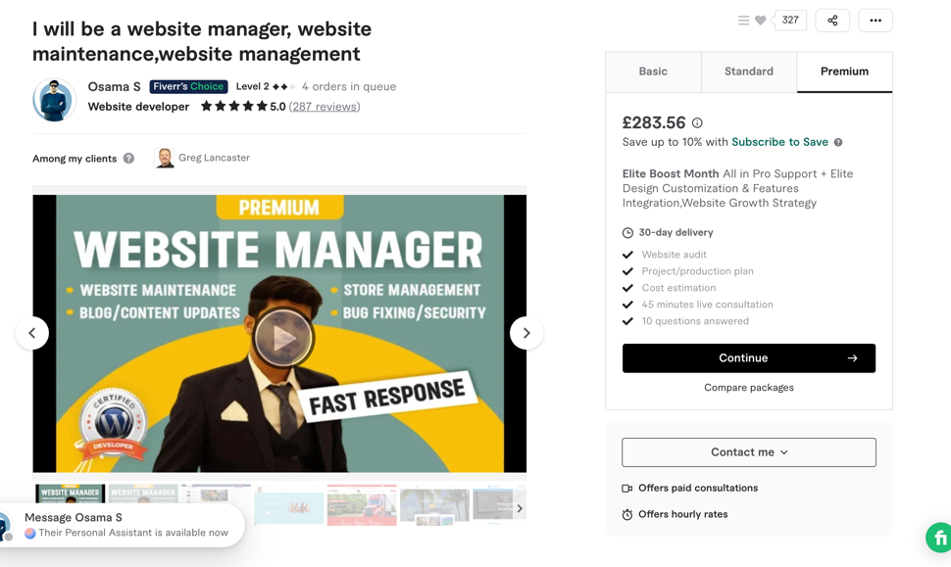

Competitive Analysis and Risk Management
The IV Toolkit functions as a mobile application exclusively created to enable pediatric nurses to prepare intravenous medications with precision and speed. The application combines BNFC and Medusa guidelines to deliver a centralised platform that automates weight-based dosage calculations leading to fewer medication errors and better workflow efficiency. The adoption of digital solutions for patient safety and compliance enhancement in healthcare makes it necessary to examine both the competitive landscape and potential risks when implementing the IV Toolkit. The section begins with a SWOT analysis that examines the app's strengths and weaknesses while identifying opportunities and threats before presenting a risk management plan to tackle the main challenges. The focus of this report is to maintain the IV Toolkit as a sustainable solution in NHS Trusts by identifying both competitive pressures and strategies for mitigation.

Competitor Analysis
In order for IV ToolKit to be unique and offer something different we need to conduct a competitor analysis. A competitor analysis is necessary when creating a business plan as you need to outline what other businesses offer and what you are considering proposing will be successful.
I conducted a competitor analysis and found there to be four competitors to IV Toolkit however, I will outline what they offer and why what IV Toolkit is offering is going to be unique. The first app is called IV Medication Gahart. They are currently #1 IV references for nurses on the app store. It offers information on over 400 intravenous drugs, including dosing, guidelines etc. The next app is IV Medications Elseviers which on the app store is #1 IV Drug Handbook and has been for 50 years. It contains information for the safe and effective administration of IV drugs. The next app is McGraw-Hill's IV drug handbook which is exclusively on the Play Store and provides guidance on the administration of IV drugs. The final app is UpToDate Leixidrug which has one review from 12 years ago. The app provides in depth drug information. You ask a question, and you get your reply.

The advantage of using IV ToolKit is that it integrates with the BNFC and Medusa which provides a hub for pediatric nurses to prepare IV medications. It’s user-centric design focuses on automating weight-based dosage calculations, thereby reducing any human error. Additionally, the apps compliance with GDPR and implementation of security measures such as multi-factor authentication ensures data protection. Especially with the app being restricted from public use and only being available for hospitals who roll onto the subscription service it becomes exclusive.

Features | IV Gahart | Elsevier (IV Handbook) | McGraw-Hill (IV Drug) | UpToDate (Lexicdrug) | IV Toolkit
Digital access | ✅ | ✅ | ✅ | ✅ | ✅
Q&A / Clinical support | ❌ | ❌ | ❌ | ✅ | ✅
Pediatric-specific content | ❌ | ❌ | ❌ | ❌ | ✅
BNFC/Medusa integration | ❌ | ❌ | ❌ | ❌ | ✅
In-app dosage calculator | ❌ | ❌ | ❌ | ❌ | ✅
MFA + GDPR compliant | ❌ | ❌ | ❌ | ✅ | ✅
Hospital only exclusivity | ❌ | ❌ | ❌ | ❌ | ✅
Offline access | ❌ | ❌ | ✅ | ✅ | ✅

SWOT Analysis
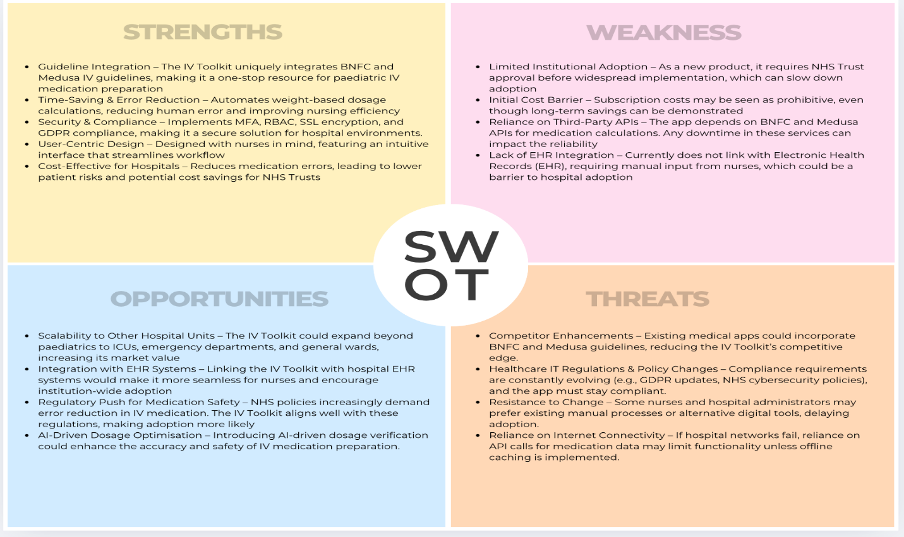
The SWOT analysis demonstrates the IV Toolkit's dominant market status as a pediatric nurse targeted specialised IV medication preparation tool. The system effectively reduces mistakes and improves operational efficiency through the combined use of BNFC and Medusa guidelines and automated dosage calculations. This is because there have been a lot of human errors onwards when IV medication was being made which was discussed by the clients in TB1. The inclusion of MFA and RBAC security protocols together with GDPR compliance establishes the IV Toolkit as a dependable solution for NHS systems. The implementation obstacles consist of institutional adoption barriers combined with subscription cost issues alongside dependency on third-party APIs. The growth potential exists through EHR integration and AI-based dosage optimisation but faces threats from competing medical apps and changing NHS regulations. By addressing these factors effectively, the IV Toolkit will maintain its role as a competitive and valuable tool for pediatric healthcare.

Risk Management

The IV Toolkit needs to tackle multiple critical challenges to minimise potential risks. The risk of service outages from relying on BNFC and Medusa APIs can be reduced by implementing offline caching methods to maintain continuous access to essential guidelines. Healthcare organisations need to implement MFA and SSL encryption along with routine security audits to protect against data breaches while staying compliant with both GDPR and NHS data protection standards. NHS Trust adoption barriers can be overcome through pilot programmes and proof of how the app cuts medication errors while boosting workflow efficiency. This was something the client wanted to include so that the hospitals get a good look at what the app offers so they can enrol in the service. The IV Toolkit must use adaptive pricing options combined with transparent ROI evidence to resolve subscription cost worries. The toolkit should incorporate EHR integration to streamline nurses' patient data entry and retrieval processes for better adoption. The IV Toolkit ensures high reliability and security while maintaining a competitive edge through proactive risk management.

Conclusion

The IV Toolkit offers an essential solution to pediatric IV medication preparation through its efficient time-saving features while reducing errors and improving security. Institutional adoption difficulties and regulatory compliance requirements along with competitive pressures present manageable obstacles through implementation of pilot studies and offline functionalities alongside AI improvements and strategic pricing models. Through ongoing cybersecurity compliance and EHR integration alongside continuous improvements the IV Toolkit becomes an essential resource for NHS Trusts which leads to better efficiency and patient safety standards.

References
NHS England (2022). National Patient Safety Incident Reports – Medication Errors. [online] Available at: https://www.england.nhs.uk/patient-safety
Group 8 (2024). Primary User Research: Interviews with NHS Paediatric Nurses, CI6415 Digital Entrepreneurship Module, London.
Kimes, S.E., & Chase, R.B. (2019). "The impact of SaaS models in healthcare." Journal of Healthcare Management, 64(6), 413-424.
Van der Meulen, A. (2021). "Subscription-based revenue models in digital health." Healthcare Business & Technology.

https://www.fiverr.com/app_cake/do-figma-to-flutter-mobile-app-design-for-ios-and-android-app-using-flutter?context_referrer=search_gigs_with_recommendations_row_3&source=drop_down_filters&ref_ctx_id=2cee84713b9f4ef78954d9645ced6220&pckg_id=1&pos=1&ad_key=cbe24507-6438-4e2b-92f9-e77124bb89e1&filtered_price=0.00%2C3563.43&context_type=auto&funnel=2cee84713b9f4ef78954d9645ced6220&ref=gig_price_range%3A0%2C2887&seller_online=true&imp_id=d9b2de0d-7d0b-46d3-819f-e13f3d929a15

https://www.fiverr.com/agrariannadeem/do-webflow-website-development-or-convert-your-figma-design-into-webflow?context_referrer=search_gigs_with_modalities&source=choice_modalities_pricing&ref_ctx_id=a8618efbb03d4795ba272c5177b400e4&fiverr_choice=true&pckg_id=1&pos=2&context_type=auto&funnel=a8618efbb03d4795ba272c5177b400e4&imp_id=87eac7e9-f70b-4e03-9182-78e7187331bd

https://www.fiverr.com/osamashamim/do-website-management-or-wordpress-maintenance?context_referrer=search_gigs_with_recommendations_row_3&source=drop_down_filters&ref_ctx_id=572bd50a516e45ba8067009cb6f083f6&pckg_id=1&pos=4&ad_key=6a1df147-9b26-4e8e-b018-826bf59b6879&filtered_price=0.00%2C350.54&context_type=auto&funnel=572bd50a516e45ba8067009cb6f083f6&ref=gig_price_range%3A0%2C284&fiverr_choice=true&imp_id=5858d4e7-be02-42c5-a601-d7d28fc6175a

https://www.fiverr.com/arvinio/build-a-mobile-app-in-flutter-or-flutterflow-or-react-native?context_referrer=search_gigs_with_recommendations_row_3&source=top-bar&ref_ctx_id=e110952637094e1189d84cda5f8b62ad&pckg_id=1&pos=2&ad_key=fd08f562-83fc-4273-98cc-5c5af08f4f5f&context_type=auto&funnel=e110952637094e1189d84cda5f8b62ad&imp_id=9ae8787c-8925-44e0-b991-9d1d4e736ea3

